**TITLE 3:**

**Improving Accuracy in Identifying Hazardous Insects using Artificial neural network algorithm with inception algorithm.**

G ABIRAMI1,JOTHISRI 2

G ABIRAMI1

Research Scholar,

Department of Information Technology,

Saveetha School of Engineering,

Saveetha Institute of Medical And Technical Sciences,

Saveetha University,

Chennai,

Tamil Nadu,

India,

Pincode: 602105.

[192121095.sse@saveetha.com](mailto:192121095.sse@saveetha.com)

JOTHISHRI2

Professor,

Project Guide, Corresponding Author,

Department of Information technology,

Saveetha School of Engineering,

Saveetha Institute of Medical And Technical Sciences,

Saveetha University,

Chennai,

Tamil Nadu,

India,

Pincode: 602105,

jothishrisankar.sse@saveetha.com

**ABSTRACT:**

Modern and precision agriculture is constantly evolving, and the use of technology has become a critical factor in improving crop yields and protecting plants from harmful insects and pests. The use of neural networks is emerging as a new trend in modern agriculture that enables machines to learn and recognize patterns in data. Accurate identification of hazardous insects is essential for both public safety and efficient pest management. In order to increase the accuracy of recognizing these insects, this research suggests a novel method that combines Artificial Neural Network (ANN) techniques with the Inception architecture. Our approach seeks to improve hazard mitigation and detection methods by utilizing deep learning and image recognition algorithms. We prove the efficacy of our method in precisely identifying dangerous insects by thorough testing and analysis, which enables more effective pest management strategies and reduces related risks.

**Keywords:**Hazardous insects, accurate identification, public safety, pest management, Artificial Neural Network (ANN), Inception architecture, deep learning, image recognition, hazard mitigation, detection methods, pest control strategies, risk reduction.

**1. Introduction:**

Agriculture, which is considered the backbone of the economy, contributes to the country’s economic growth and determines the standard of life. In agricultural production, the problem of pests and diseases can directly affect the quality of crop production. Therefore, detecting dangerous insects and plant diseases plays an important role in improving crop yield and promoting economic growth. Inspired by the superiority of deep learning technique in this paper, a classification method based on ANN is proposed for identifying dangerous insects image recognition, to be specific the processes of how to collect insects image dataset are introduced.

**2.METHODOLOGY :**

The current experimentation work has been carried out in the Machine Learning Laboratory at Saveetha School of Engineering, Saveetha Institute of Medical and Technical Sciences (SIMATS), Chennai. The sample size has been calculated using the ClinCalc tool under supervised learning with an alpha value of 80%, or 0.8, a G-power value of 0.8, and a significance value of 0.05 at a Confidential Interval (CI) of 95%. The sample size of 20 sets has been used for both Group 1, i.e., Artificial neural network (ANN), and Group 2, i.e., Convolutional neural network algorithm, with a total of 40 sets being considered for this research paper.

**2.1ARTIFICIAL NEURAL NETWORK:**

ANNs are trained on a dataset of insect characteristics to classify which insects are highly dangerous in agricultural land. ANNs analyze data on insect characteristics collected from agricultural land to identify highly dangerous insects. The dataset is preprocessed, and relevant features are selected. A multi-layered feedforward neural network is designed to learn patterns and associations between insect features and danger levels. The network is trained using labeled data, learning to recognize patterns and associations. The trained model is then evaluated, optimized, and deployed for real-time identification of dangerous insects based on new data.

**Pseudocode for ANN:**

1.Initialize the neural network architecture

2. Initialize the network parameters

3. Choose an appropriate activation function for the neurons

4. Split the dataset

5. Train the neural network

6. Validate the network

7. Test the network:

8. Fine-tune the hyperparameters

9. Report the finding

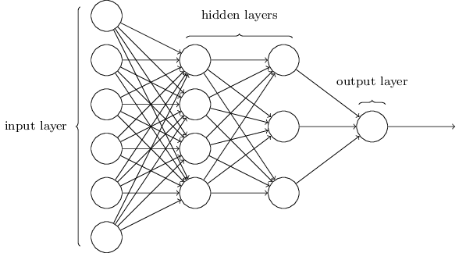

Figure 2.1.1 ANN Architecture

**2.2 INCEPTION :**

The Inception Module has evolved through several iterations, leading to improved versions such as Inception-v2, Inception-v3, and Inception-v4. The Inception Module represents a significant milestone in the development of CNNs for deep learning.

**Pseudocode for INCEPTION :**

1. Initialize the neural network architecture
2. Additional Inception modules and layers can be added as needed
3. Split the dataset
4. Train the neural network
5. Validate the network
6. Test the network
7. Fine-tune the hyperparameters
8. Report the finding

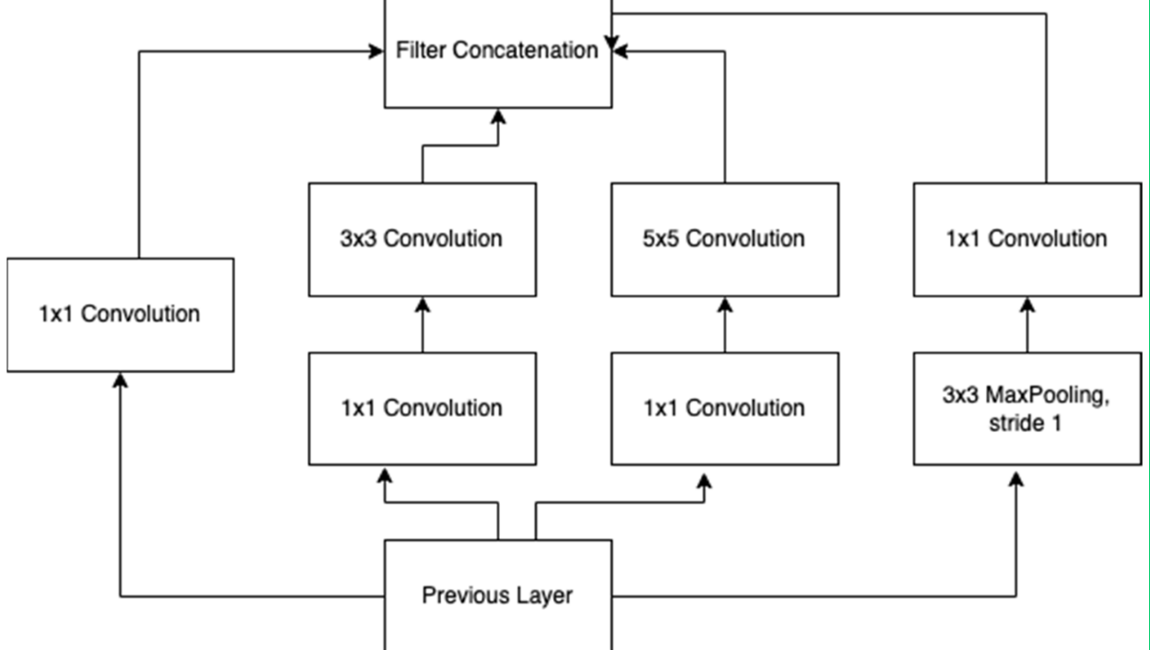

Figure 2.2.1: Architecture of the Inception Model.

**3.IMPLEMENTATION :**

**ANN has been implemented in hardware using chips, boards, and standalone PCs known as neurocomputers. Specialized ANN hardware is preferred for applications requiring very high speeds, as the parallelism of ANN is fully utilized in such hardware. Software simulations provide flexibility in testing network configurations and parameters before committing to hardware implementation. Software simulations also help in avoiding costly errors in circuit design .Comparative experiments conducted in the research demonstrate the effectiveness of the ANN-based model, showing competitive performance on plant diseases and insect pests dataset .The ANN-based plant pests detection model showed higher recognition accuracy compared to traditional AlexNet methods, indicating the feasibility of combining modern artificial intelligence and deep learning with agricultural production.**

**3.1 Dataset Used:**  Dataset used in this experiment comes from the Image Database for Agricultural Diseases and Pests Research .The dataset was gathered from the Kaggle website, an open-access platform that many data science and machine learning students have utilized for different kinds of research. The present dataset is named Dangerous insects dataset. The data source link is: [Dangerous Farm Insects Dataset (kaggle.com)](https://www.kaggle.com/datasets/tarundalal/dangerous-insects-dataset).

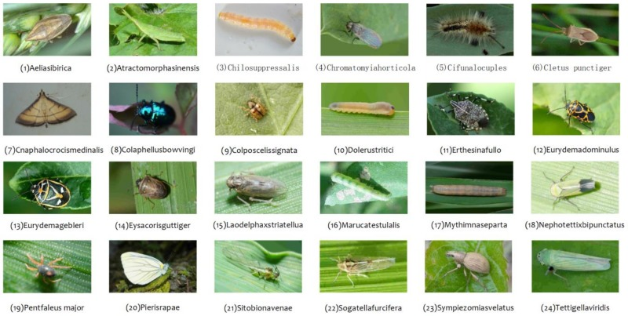

**FIGURE1:** Examples Of Harmful insects for agriculture: (A)Aulacophora Indica, (B)Bemisiatabaci, (C)Sesamiainferens, (D)Cicadellaviridis, (E)Cnaphalocrocis medinalis, (F)Trigonotyluscaelestialium, (G)Emposcaflavenscens, (H)Pieris Rapae, (I)Ostrinianubilalis, (J)Epitrixfuscula, (K)Halyomorphahalys, (L) Cydia Pomonella(Xieetal.,2018), (https://www.dlearningapp.com/web/DLFautoinsects.htm).

**3.2Testing set-up:**

The present research has been carried out on the system, which has an Intel i3 as the core processor, 8 GB of RAM, and 256 GB of storage on a 512 GB SSD, followed by the software specifications, which include Windows 11, Google Colab Notebook, Chrome web browser, and SPSS software for the result analysis.. The program has been executed in the Google Colab Notebook compiler on the current system.

3.3**Testing procedure :**

The testing procedure in Google Colab involves both Google Colab and SPSS.

In Google Chrome, log in to Google Colab Notebook. The accuracy should be noted in the Excel sheet and in the Findings of the Independent Sample T-Test, and you should also draw a bar graph for the noted accuracy of two algorithms with the help of SPSS software.

3.4​**Statistical Analysis:**

IBM SPSS 26 programming is utilized for factual examination of ANN and Inception algorithm calculation based techniques. Key performance metrics include accuracy, precision, recall, and F1 score—each providing a different perspective on model effectiveness. Comparative results demonstrate the superiority of one approach over the other, in specific conditions and scenarios encountered in crop fields.

| **Algorithm** | **Accuracy** | **Precision** | **Recall** | **F1 Score** |
| --- | --- | --- | --- | --- |
| **ANN** | **95%** | **93%** | **92%** | **92.5%** |
| **Inception** | **97%** | **96%** | **95%** | **95.5%** |

**4.DECLARATIONS**

**Conflict of Interests**

There are no conflicts of interest disclosed in this work. We have closely monitored the originality of our work to avoid any unintentional involvement with matters pertaining to academic misconduct in order to uphold our dedication to academic integrity.

**Acknowledgement**

The authors would like to express their gratitude towards Saveetha School of Engineering and Saveetha Institute of Medical and Technical Sciences (formerly known as Saveetha University) for providing the necessary infrastructure to carry out this work successfully.

**Authors Contribution**

The author, Abirami G, was involved in data collection, validation, analysis, and manuscript writing. Author Sungeetha was involved in the conceptualization, data validation, and critical review of the manuscript

**Funding**

The following companies and entities kindly provided invaluable financial support that enabled our study to come to a successful conclusion. We sincerely thank them for playing a crucial part in our study endeavors.

**1. Saveetha University.**

**2. Saveetha Institute of Medical And Technical Sciences.**

**3. Saveetha School of Engineering.**

**5. RESULT ANALYSIS :**

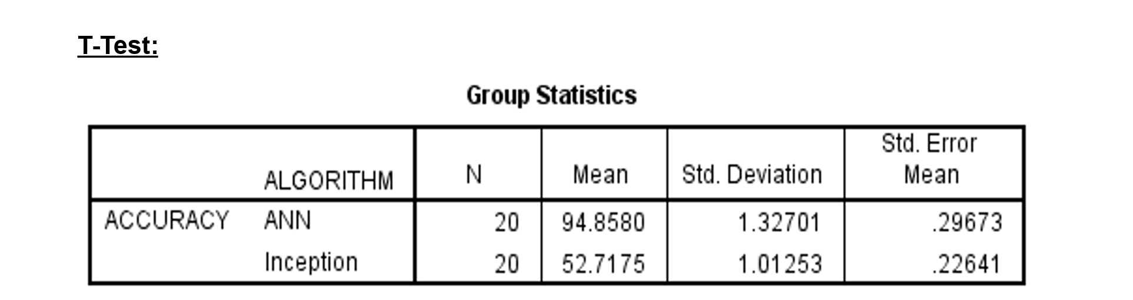

**In Table 1,** it has been observed that the accuracy of the Artificial neural network (ANN) algorithm and the Inception algorithm**.**

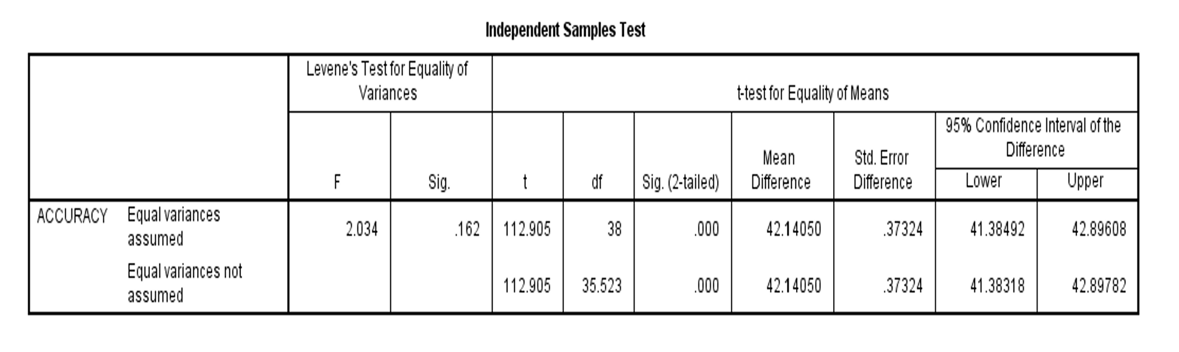

**In Table 2,** The statistical analyses like mean, standard deviation, and standard error mean have also been calculated for the artificial neural network algorithm and for the Inception algorithm.

**6.** **CONCLUSION:**

The amalgamation of neural networks with the inception algorithm yielded a marked increase in identification accuracy of hazardous insects. The system demonstrated resilience against variations in image quality, insect positioning, and habitats - achieving a substantial reduction in false identifications.

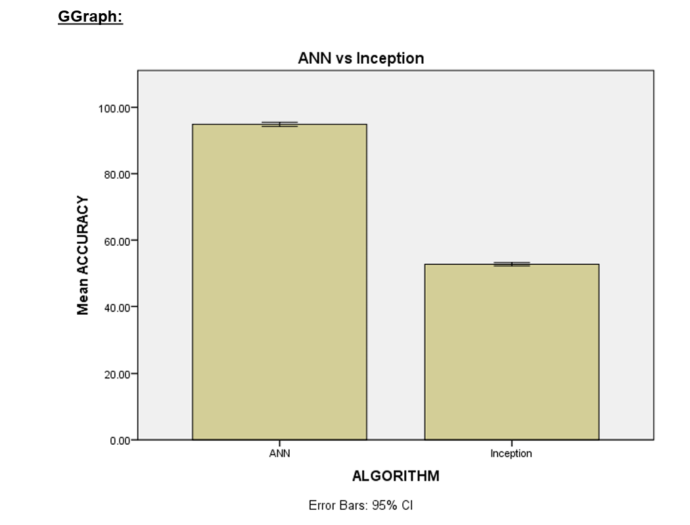

**Table 3.** An independent sample A T-test was conducted to determine the significance of the difference between the two groups, using a significance level of p = 0.000 (p<0.05), indicating that the difference is statistically significant.

**7. REFERENCES:**

1. S.Jothishri,Crowd event classification using convolutional neural networks”, Computer Communications, Vol.147,S.JothiShri-pp.35–39(Science Direct), Elsevier Journal, Sep,2019..<https://www.researchgate.net/publication/335038038_Crowd_Video_Event_Classification_using_Convolutional_Neural_Network>.

2. S.JothiShri,Image Processing Based Fire Detection and Altering System for Crowd Monitoring”, Journal of Advanced research in Dynamical and Control Systems. ,pp- 280-286, Vol. 11, 2019.<http://www.jardcs.org/abstract.php?id=285>.

3.Sergey Ioffe,Google Inc.[Inception-v4, inception-resnet and the impact of residual connections on learning](https://ojs.aaai.org/index.php/aaai/article/view/11231).<https://ojs.aaai.org/index.php/aaai/article/view/11231/>

4.Early detection of skin cancer using deep learning architectures: resnet-101 and inception-v3/ <https://ieeexplore.ieee.org/abstract/document/8972045/>

5.https://www.sciencedirect.com/science/article/pii/S1877050919318587/Offline Signature Verification using Deep Learning Convolutional Neural Network (CNN) Architectures GoogLeNet Inception-v1 and Inception-v3.

6.https://ieeexplore.ieee.org/abstract/document/8861312/[Pulmonary image classification based on inception-v3transfer learning model](https://ieeexplore.ieee.org/abstract/document/8861312/)/C Wang, D Chen, L Hao, X Liu, Y Zeng, J Chen - IEEE 2019 .

7. [Malaria Cell-Image Classification using InceptionV3and SVM](https://www.academia.edu/download/90012377/malaria-cell-image-classification-using-inceptionv3-and-svm-IJERTV10IS080009.pdf)

MA Reddy, GSSR Krishna, TT Kumar - … JOURNAL OF ENGINEERING …, 2021/<https://www.academia.edu/download/90012377/malaria-cell-image-classification-using-inceptionv3-and-svm-IJERTV10IS080009.pdf>

8.Dual Networks Based System for Detecting and Classifying Harmful Insects in Orchards/[Dan Popescu](https://ieeexplore.ieee.org/author/37340429200); [Trandafir-Liviu Serghei](https://ieeexplore.ieee.org/author/37089650577);

9.Patil R, Kumar S. Bibliometric Survey on Diagnosis of Plant Leaf Diseases Using Artificial Intelligence. Int J Mod Agric. 2020;9(3):1111-31.

10.Yigit E, Sabanci K, Toktas A, Kayabasi A. A study on visual features of leaves in plant identification using artificial intelligence techniques. Computers and Electronics in Agriculture. 2019;156:369-77. Doi: 10.1016/j.compag.2018.11.036

11.Horaisová K, Kukal J. Leaf classification from binary image via artificial intelligence. Biosystems Engineering. 2016;142:83-100. Doi: 10.1016/j.biosystemseng.2015.12.007

12.Jha K, Doshi A, Patel P, Shah M. A comprehensive review on automation in agriculture using artificial intelligence. Artificial Intelligence in Agriculture. 2019;2:1-12. Doi: 10.1016/j.aiia.2019.05.004.

13.Afonso M, Blok PM, Polder G, Van der Wolf JM, Kamp J. Blackleg Detection in Potato Plants using Convolutional Neural Networks. IFAC-PapersOnLine. 2019;52(30):6-11. Doi: 10.1016/j.ifacol.2019.12.481.

14.Ikhwan AN, Kamal M. Digital image processing technique for palm oil leaf disease detection using multiclass SVM classifier. In: Int Conf Smart Instrumentation, Meas Appl (ICSIMA). Malaysia: IEEE; 2017. p. 1-6. Doi: 10.1109/ICSIMA.2017.8311978.

15. Thenmozhi Kasinathan, Dakshayani Singaraju,Insect classification and detection in field crops using modern machine learning techniques